## Performance Analysis of TCP Variants

Zetao Wang and Yidong Wang

Northeastern University

360 Huntington Ave., Boston, Massachusetts 02115

wang.zet@husky.neu.edu,wang.yid@husky.neu.edu

1 Introduction

The original design of the Transmission Control Protocol (TCP) worked reliably, but was unable to provide acceptable performance in large and congested networks. So several TCP variants were

proposed in order to improve the performance of Transmission Control Protocol under congested networks. For example, a TCP variant named Reno improve the performance of TCP by fast retransmit and fast recovery. Each TCP variant have their mechanisms to control and avoid congestion.

We do a research on the contrast the performances of different Transmission Control Protocol under three experiments:

1. In the first experiment, we set different CBR flow rate and test TCP variants’ performance.
2. In the second experiment, we test the allocation of a bandwidth while running 2 different TCP variants on it.
3. In the third experiment, we test the influence of the queuing discipline used by nodes on the overall throughput of flows.

In this paper, the methodology of the three experiments would be proposed in section2,

and talk about the above three experiments though section 3, 4 and 5, and the last section 6 is the summary of our work.

2 Methodology

2.1conduction of experiments

2.1.1conduction of the first experiment

By setting CBR rate from 1 to 10, we will compute throughput, latency, packet loss using the formulas below from the output file:

Latency = Propagation + Transmit + Queue

Propagation = Distance/SpeedOfLightTransmit = Size/Bandwidth

Throughput = TransferSize/TransferTime

TransferTime = RTT + 1/Bandwidth × TransferSize

PacketLosses = PacketSend - PacketReceived

PacketLossesRatio = Number of lost packets / Number of received packets

2.1.2conduction of the second experiment

By setting different start time, we will calculate throughput, latency, packet loss for each TCP variants that is using in the network.

It might the listed situations below:

- One starts ahead the other one, and it reaches stable status.

- One starts ahead the other one, and it does not reach stable status.

- The two TCP variants start simultaneously.

By setting the variable random as True, we set the sending packet behavior of CBR as randomly.

2.1.3conduction of the third experiment

By setting queue type, we will compute throughput, latency, packet loss to test the performance of the TCP variants and CBR flow over time.

2.2 Analysis Tool

These experiments were conducted using NS-2, an event driven network simulator,

which consist of event scheduler and network component.

We use two ways to filter out the data from the .tr files and to measure the corresponding performance parameters: first way is using python to filter and compute the parameters. The second way is using uses a command written in perl called "column" that selects columns of given input combined with awk.

3 TCP Performance Under Congestion

3.1 topology of experiment 1

Experiment 1 is set up in the topology in Figure 3-1. A constant CBR source is added at N2 and sink at N3. A single TCP stream is added from N1 to N4. And the TCP stream varies from Tahoe, Reno, New Reno and Vegas

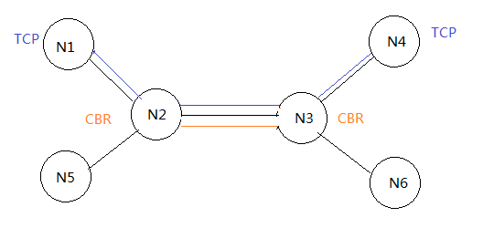

Figure 3.1 topology of experiment 1

In the experiment, the CBR flow rate varies from 1Mbps to 10Mbps, to change the congestion condition in the network. Under each constant CBR flow rate, the throughput, latency and drop rate of each TCP flow would be recorded. By analyzing the experiment result, we could make a comparison of how the four TCP variant react to the presence of congestion.

By setting CBR rate from 1 to 10Mbps, we will compute throughput, latency, packet loss.

3.2 Average Throughput

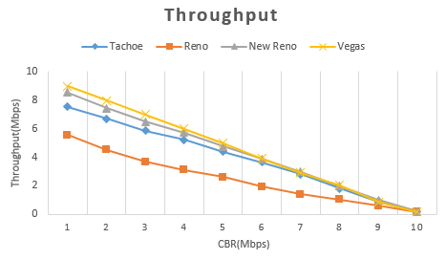

Figure 3.2.1 Throughputs

We calculate Average Throughput by dividing total packets received at N4 by the total running time. Figure 3.2.1 is the result of average throughput (CBR change from 1~10 Mbps) contrast between Tahoe, Reno, New Reno and Vegas.

And we could tell from figure 3.2.1 that with the CBR flow rate increasing from 1~10Mbps, the throughput of all four kinds of TCP flows would decrease. Because the increasing CBR flow rate aggravated the congestion in the network, so TCP flows under all the four TCP variants’ throughput decreased.

But, under different TCP variants, the performance of TCP throughputs are different: Vegas get the highest average throughput. New Reno get the second highest average throughput and then Tahoe keeps the third highest average throughput. Reno has the lowest average throughput. Because the TCP Vegas use congestion avoidance algorithm which emphasize packet delay rather than packet loss, it controls its congestion window by detecting the RTT. So the size of congestion window is more adaptable to the latest network status, that’s why TCP Vegas could have higher throughput in the congestion situation than others. New Reno is modified from Reno, the fast retransmit performed much better than Reno: Each duplicate ACK triggers a retransmission, but in Reno, three duplicate ACK triggers a retransmission. So New Reno performed better than Reno. Tahoe will just retransmit after detecting a packet dropped.

3.3 Average Latency

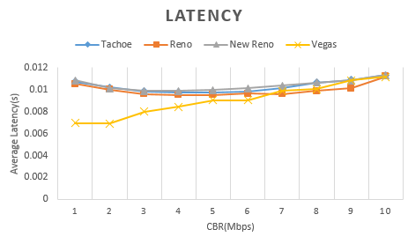 Figure 3.2.2 Latency

Vegas has lowest latency of TCP Flows than other variants in this case, TCP Vegas detects congestion in advance based on the RTT instead of an actual packet drop, therefore Vegas will send fewer packets to the network when the network is under congestion, caus-ing less average latency. The TCP flows of Tahoe, Reno and New Reno have similar latency. Because Vegas have efficient congestion window control algorithm, TCP Vegas could detect and avoid the congestion more easily, so the Latency is shorter than Reno, New Reno and Tahoe.

3.4 Drop Rate of TCP Flows

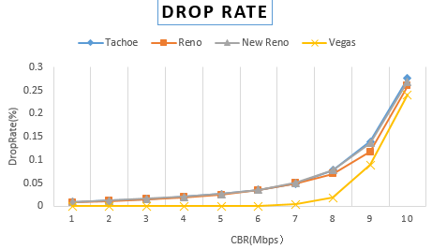

Figure 3.4 drop rate

We can see from the figure 3.4 that the higher the CBR Flow is, the higher the drop rate is. It is obvious that the high CBR flows mean the more congestive the network is, so when the network is more congestive, the drop rate is increasing.

When the CBR from 1Mbps to 7 Mbps, we can see that Vegas’s drop rate is much lower than the other three kinds of TCP variants. Reno, New Reno and Tahoe have similar drop rates. And when CBR flow from 7 Mbps to 9Mbps, all the drop rates grows fast but Vegas still has the lowest drop rate, and other three variants still have similar drop rates. When CBR flow grows from 9 to 10Mbps, the drop rates under all of the variants grow rapidly and all of the variants drop rate become similar. Because Tahoe, Reno and New Reno are using Additive Increase Multiplicative Decrease algorithm to control the congestion window and they use detecting dropped packets to change their congestion window. On the other hand, TCP Vegas use detecting RTT rather than dropped packets to control its congestion window. It can detect the congestion earlier than Tahoe, Reno and New Reno, and then take action to avoid the congestion. That’s why its drop rate is the smallest.

3.5 Summary

In overall, TCP Vegas reacts a relatively better performance than other variants due to its congestion avoidance algorithm.

4 Fairness Between TCP V-ariants

4.1 topology of experiment 2

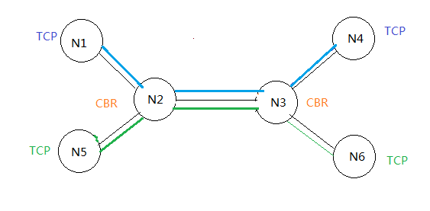

We compare the four combinations of variants: Reno/Reno, New Reno/Reno, Vegas/Vegas and New Reno/Vegas .We add

A TCP flow from N1 to N4 and add another TCP flow from N5 to N6 to compete the one on N1 and N4.

4.2 Reno vs Reno

From this comparation, we can see that their performance almost the same in throughput, latency and drop rate. Overall they are overlapping with each other. Therefore in this case, both TCP Reno act fairly and share the network bandwidth equally. Because they are the same variants, they have the same functionalities, they share the network bandwidth equally between each other. Reno and Reno flows are fair to each other.

4.3 New Reno vs Reno

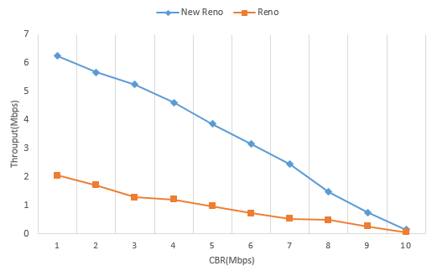

4.3.1 Throughput with competition

From figure 4.3, we can see that New Reno’s throughput is larger than Reno until the CBR become 10Mbps. Because both of the variants begin as a slow start, and both of them have fast retransmit and fast recovery, but New Reno will retransmit after one duplicate ACK while Reno will retransmit after received three duplicate ACK, and New Reno will reduce its window size to ssthresh in order to avoid slow start from one byte. So we can see New Reno recover much fast than Reno. And the throughput is much bigger than Reno. And because of the New Reno retransmit faster than Reno, so at first the Latency is much lower than Reno, but when the CBR arrive a threshold, the Latency of New Reno and Reno become almost the same.

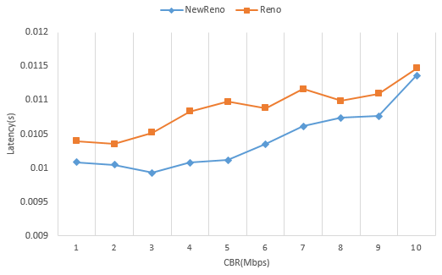

4.3.2 Latency with competition

And when we compare the Drop Rate of these two variants, it is almost the same.

Generally, when TCP New Reno is competing with TCP Reno, Reno and New Reno are not fair to each other, New Reno will gain an advantage of better performance.

4.4 Vegas vs Vegas

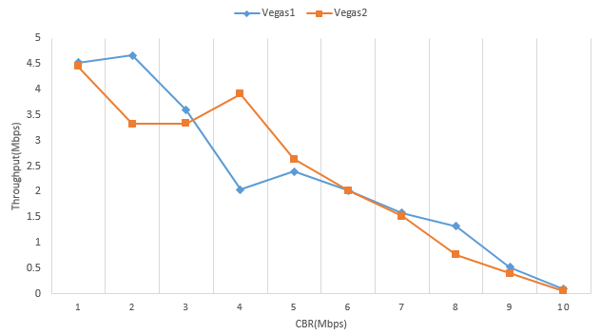

4.4.1 Throughput

TCP Vegas detects congestion at an incipient stage based on increasing Round-Trip Time (RTT) values of the packets in the connection.

The algorithm depends heavily on accurate calculation of the Base RTT value. If it is too small then throughput of the connection will be less than the bandwidth available while if the value is too large then it will overrun the connection.

When one Vegas increases the sending rate, the other may detect an increasing RTT and thus decrease the sending rate. That’s why the throughputs are changing. When the CBR ﬂow rate is bigger than 7Mbps, the two cannot share the bandwidth quite well. And packet loss rate and latency of the two TCP Vegas flows are similar.

Overall, both Vegas compete fairly in the experiment. But due to the congestion avoidance algorithm, both variants are oscillating in the result.

4.5 New Reno vs Vegas

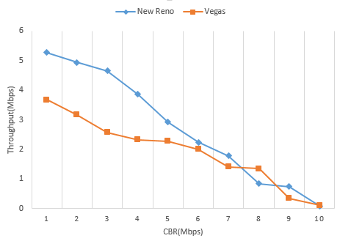

4.5.1 Throughput

We can see from figure 4.5.1 that New Reno gains a better throughput. Because New Reno will keep sending packets until a RTO happens, while the Vegas will detect the congestion by RTT. At first New Reno throughput is huge, so the RTT will be long, so the throughput of Vegas will be low. And when CBR grows from 1 to 10 Mbps, the network will be more congestive, so the throughput of New Reno will be deceased.

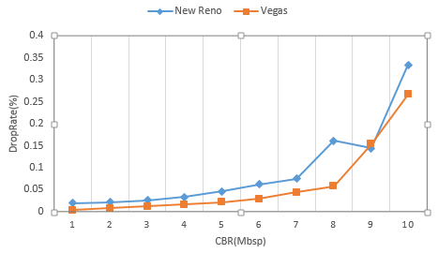

4.5.2 Drop Rate

We can see from 4.5.2 the drop rate under the New Reno and Vegas are similar when the CBR flow is not huge, but when the CBR flow grows to 9Mbps the drop rate under New Reno increased rapidly, but the drop rate under Vegas still stable, because the Vegas can detect the congestion situation of the network, so it can control this throughput in order to decrease the drop rate.

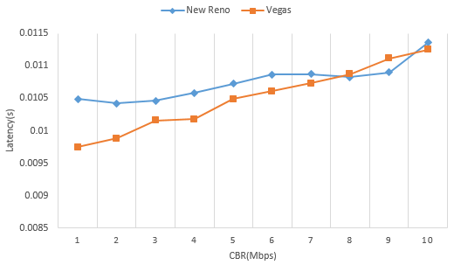

4.5.3 Latency

In conclusion when Vegas is inter-operated with other versions like New Reno. In this case, performance of Vegas degrades because Vegas reduces its sending rate before New Reno as it detects congestion early and hence gives greater bandwidth to co-existing TCP Reno flows.

5 Influence of Queuing

5.1 topology of experiment 3

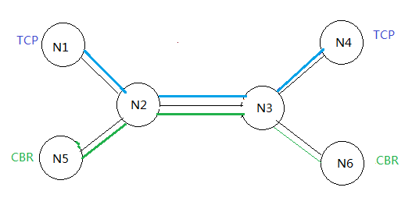

5.2 Throughput

In this experiment, we adding a TCP flow from N1 to N4, and a CBR/UDP flow from N5 to N6. When the TCP flow stabilized we start CBR flow. Performing the experiments with TCP Reno and SACK under different queue algorithms to see the performance of TCP and CBR flow over time. We let TCP flow starts at 0s, and CBR flow starts at 15s. Give enough time to make TCP flow stable.

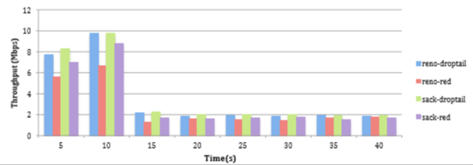

5.2.1 Average throughputs of TCP

As shown in figure 5.2.1, when CBR flow start, it grabs bandwidth from TCP flow, and the TCP flow’s throughput decrease mar-kedly, CBR flow has no reaction to congestion announcement. That means both of the algorithms cannot provide fair bandwidth to difference flows, such as TCP flows and CBR flows. Both of the queue algorithms treat different flows without difference, so it cannot protect TCP flows from misbehaving flows as the CBR flow in this experiment.

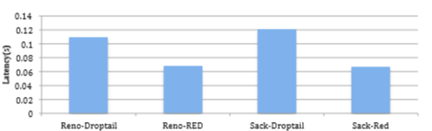

5.2.2 Latency of TCP Flows

From Figure 5.2.2, although the end-to-end latency for both TCP flows is shorter when using RED as their queuing strategy than that of DropTail, RED does not provide higher throughput for TCP flows. As shown in Figure 5.2.2, the combination of SACK and DropTail provides highest throughput than the other combinations.

6 Conclusion

By analyzing the results stated above, we can come to following conclusion: Although TCP Vegas has a better performance than the other TCP Variants under the congestion situation, the performance of Vegas is unsatisfactory when there are other TCP Variants in the network. That is, in today’s network with most of TCP flows are using Reno, Vegas could not have such good performance in experiment 1, even worse than the TCP Reno. If we want to use TCP Vegas to improve our network, we should ask everyone to use TCP Vegas too.

Additionally, although RED could improve our network by the better absorption of packet bursts and avoiding TCP flow synchronization, RED does not have a good protection to deal with the misbehaving flows, such like UDP and CBR. TCP Flows performs worse in RED than Drop Tail with a constant CBR flow. So we should better only use the queuing of RED in the network that most flows are TCP flows. Another solution to this problem is to separate two queues for TCP flows and the other flows in the router, and to use RED for the TCP flows. The contributions of this paper are as follows. Firstly, we analyzed the performance of different TCP variants. Secondly, we discussed the feasibility of using the variant with the “best” performance in the reality. Thirdly, the performance of different queuing method is analyzed. Further work includes discussing the performance of TCP variants in a more complicated network situation. And how to improve Vegas and RED to make them more feasible and efficiency in modern network is also interest to us.